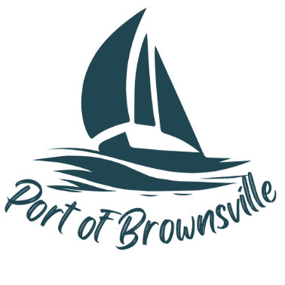

**AGENDA**

Special Meeting

Port of Brownsville Commission

Monday January 6th, 2025 at 4:00 PM

9756 Ogle Rd, Bremerton, WA 98311

And VIA ZOOM

1. Open Meeting / Call to Order
2. Executive Session
   1. The Commission will now adjourn into an executive session to consider the minimum price at which real estate will be offered for sale or lease – RCW 42.30.110(1)(c)
3. Close Meeting / Adjourn