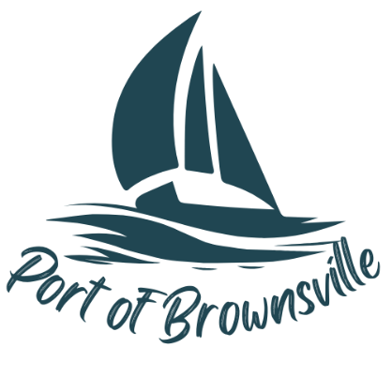

**NOTICE AND AGENDA**

Special Meeting

Port of Brownsville Commission

Wednesday January 22, 2025 at 12:00 PM

9756 Ogle Rd, Bremerton, WA 98311

The Board of Commissioners of the Port of Brownsville will hold a Special Commission Meeting on the date and time stated above at the location described above in the Commission Room at 9756 Ogle Rd. for the purposes of conducting, considering, and/or acting on the items listed below:

1. Open Meeting / Call to Order
2. Interview for Commission District #2
   1. Mike Williams
3. Commission Port Walk
4. Interview for Commission District #2
   1. Vanessa Ressler
5. Recess into Executive Session
   1. pursuant to RCW 42.30.110(1)(h) Qualifications of an applicant/candidate for appointment to elective office