REQUEST FOR PROPOSALS FROM QUALIFIED VENDORS
LANDSCAPE MAINTANANCE

Proposal Due: March 12, 2025, 5:00 (PST)

Port of Brownsville
9790 Ogle Rd
Bremerton, WA 98311

Attention: Robyn Dally
Port Manager

Notice of Request for Proposals

RFP: Landscape Maintenance
The Port of Brownsville a small public port in Bremerton, WA is seeking a qualified service to install Landscape Maintenance for the Marina and Port Properties. Full scope & RFP can be obtained by contacting POB@portofbrownsville.org. The deadline to submit bids by 3/12/25. All further questions can be sent to POB@portofbrownsville.org

Notice to be published: Bid Published to Bonfire.

Notice is hereby given that bids for, The Port of Brownsville Landscape Maintenance located in Bremerton, Washington will be received at the Administrative Offices of the Port of, Brownsville, 9790 Ogle Rd, Bremerton, Washington until 5:00 p.m., Wednesday, March 12, 2025. The official time shall be taken from the designated clock at the Administrative Offices. Any bids received after the specified time and date will not be considered. Bids will then be publicly presented at the Meeting of the Port of Brownsville Commission at 6:00 pm on the same date.

The scope of work for this project consists of furnishing all labor, materials, and equipment necessary for the project identified above including the following major work items:

- Vendor shall furnish all labor, tools, specialized equipment, materials, supplies, supervision, and transportation to perform landscape maintenance services as specifically outlined in this section.
- Operators shall be licensed for all functions, including pesticide, fertilizer, herbicide, and flagging where required.
- Vendors shall ensure that employees comply with all the State of Washington Industrial and Kitsap County regulations, policies, and practices
- Vendor shall establish a weekly work schedule; the maintenance shall be scheduled on day(s) and time(s) as mutually agreed upon by the Port and the vendor. To the extent possible, work shall be performed on the same day each week, In no case shall work be performed more than forty-eight (48) after the regularly scheduled day without notification and consent of the Maintenance Supervisor. Equipment intensive work such as mowing, edging, and blowing done at the work site shall not commence before 7:00am on weekdays and 9:00am on weekends. No work on Sundays or Holidays.
- Vendor’s shall select their own sites for disposal of debris and unsuitable materials collected under the conditions of the contract. In no case shall debris and unsuitable materials be disposed upon Port property or any property contiguous thereto.
- Landscape maintenance services to be completed include but are not limited to:
- General Lawn Care
  - Mowing
    - Mowing done during the growing season end of April to October. Mowing from November to March shall be at the discretion of the Port.
    - Vendor shall maintain all lawns at the sites covered by this agreement in a healthy, neat, and trim condition.
    - Vendor shall remove and dispose of all litter or debris from mow area prior to mowing.
    - Hard surfaces shall be left clean and free of grass and debris resulting from landscape maintenance tasks.
  - Line Trimming
    - Turf around signposts, fences, trees, shrubs, shrub beds, and other obstacles shall be trimmed.
    - Turf around vaults, valve boxes, and irrigation heads shall be trimmed as necessary to ensure proper access and operation.
    - Hard surfaces signposts, and fences shall be cleaned free of grass and debris resulting from this task.
  - Edging
    - All lawn edges shall be edged at sidewalks, curbs, walls, foundations, formal pathways, and formal edges.
- Plant Materials. Bed Areas and Tree Wells
  - Pruning
    - The Vendor shall maintain all trees, shrubs, and groundcover of the parks in a healthy, growing condition.
    - Shrubs shall be trimmed to maintain desired shape and function as needed ot provide a neat, trim appearance. Pruning to maintain the natural growth habit of native plant species is recommended.
    - Trees in streets Right of way are to be pruned to avoid sight distance or vehicle interference issues.
  - Weeds, Disease, and Pest Control
    - Landscape/planted areas/ beds shall be kept free of: weeds, leaves, litter, debris, spent blooms and diseased, insect infested or dead plants and/or trees.
    - Landscape bed areas shall be kept in a weed free condition.
  - Hard Surface Maintenance
    - The entrance drive, parking lots/areas, sidewalks, curbs, and other hard surfaces shall be kept free of leaves, litter, debris.
    - Undesired vegetation in/on sidewalks, tree grates, curbs and other hard surfaces may receive an approved herbicide application and/or shall be removed.
    - Drains, if present at the site shall be cleaned and checked during each visit and any garbage or debris shall be removed to allow for proper drainage.

General work to be completed sample schedule.
Maintenance Task | Specification Notes | Estimated Annual Frequency
Maintenance Task I: Lawn Care
Mowing | Once per week April thru October; Every other week August thru November (Weather dependent) | 23
Line Trimming and Edging | Once per week starting the second week in April and ending the second week in November (Weather dependent) | 23
Maintenance Task II: Plant Materials, Bed Areas and Tree Wells
Weed Removal | Once a week March thru November | 40
Groundcover Trimming | April, June, August, October | 4
Pruning Shrubs | February, May, August | 3
Pruning Trees | November | 1
Maintenance Task III: Hard Surfaces
Sweeping | Once a week March thru November | 40
Weed Removal | Once a week March thru November | 40
Maintenance Task IV: Natural Area Maintenance
Invasive Control | April, June, September | 3
Maintenance Task V: Other Services
Leaf Removal | Once a week October thru December | 12
Field Mowing | Every other week April through June; once in October | 14
Brush Control | February, May, August, November | 4

A non-mandatory pre-bid meeting for prospective bidders will be held Monday February 24, 2025, at 10:00 PM at the, Port of Brownsville Fire Hall at 9756 Ogle Rd, Bremerton, Wa 98311. A walk through the project site will be conducted after the meeting.

The following forms shall be executed and submitted within five (5) calendar days after Notice of Award.
1. CONTRACT – To be executed by the successful bidder for 5 years.

2. PAYMENT AND PERFORMANCE BOND – Owner provided form to be completed by Contractor’s Surety and submitted with Contractor executed Contracts.

3. CERTIFICATE OF INSURANCE – Contractor shall furnish a Certificate of Insurance and all applicable Endorsements naming the Port as additional insured on its Commercial General Liability and Automobile Liability Policies.

4. WAGE LAWS COMPLIANCE CERTIFICATION – To be submitted by Contractor with executed Contract.
5. SCHEDULE OF VALUES – To be submitted by Contractor with executed Contract.

6. MATERIAL PROCUREMENT AND CONSTRUCTION SCHEDULE – To be submitted by

Contractor with executed Contract.

7. LIST OF SUBCONTRACTORS – To be submitted by Contractor with executed Contract.

8. PROJECT LABOR RATES AND EQUIPMENT RATES FOR CHANGE ORDER WORK - To

be submitted by Contractor and Subcontractors with executed Contract.

9. CONTRACTOR’S W-9 – To be submitted by Contractor with executed Contract.

The following shall be filed prior to Notice to Proceed.
1. STATEMENT OF INTENT TO PAY PREVAILING WAGES – To be filed immediately by the Prime Contractor after Contract is awarded and before work begins and subsequently by all those providing labor on the project.

BIDS - Having carefully examined the site(s), bid documents, and specifications for Port of Brownsville Security Cameras located in Bremerton, Washington the undersigned proposes to furnish all labor, materials and equipment required to perform all work in accordance with the above named documents for the following price. The Total Bid Amount includes all work, regardless of whether or not it is specifically itemized below.

BID SCHEDULE: Port of Brownsville Security Cameras
Maintenance Task | Cost | Number | Total
Maintenance Task I: Lawn Care
Mowing Non-Irrigated Areas |  | 23
Line Trimming and Edging |  | 23
Maintenance Task II: Plant Materials, Bed Areas and Tree Wells
Weed Removal |  | 40
Groundcover Trimming |  | 4
Pruning Shrubs |  | 3
Pruning Trees |  | 1
Maintenance Task III: Hard Surfaces
Sweeping |  | 40
Weed Removal |  | 40
Maintenance Task IV: Natural Area Maintenance
Invasive Control |  | 3
Maintenance Task V: Other Services
Leaf Removal |  | 12
Field Mowing |  | 14
Brush Control |  | 4
SUB-TOTAL: $
9.6% WSST: $
TOTAL BID AMOUNT: $

WITHDRAWAL - The above proposal will not be withdrawn within forty-five (45) days after the actual date of the opening hereof.

CONTRACT - If the undersigned be notified of acceptance of this Proposal within forty-five (45) days of the time set for opening of bids, they agree to execute a contract for the above stated sum, and shall bond their work as required by law and that they will begin work within ten (10) days after Notice to Proceed. The undersigned also agrees to execute the contract contained in this Bid Solicitation without modification.

SIGNING AUTHORITY – By signing below, the undersigned hereby acknowledges that they are authorized and duly bound to execute this Bid Proposal Form on behalf of the Contractor and that their signature is binding upon the Contractor. The signing party further certifies that the Contractor represented has visited the Port of Bellingham’s website before the bid due date and time to familiarize themselves with the bid documents and all changes made via Addendum.

CONTRACTOR VERIFICATION - The bidder is instructed to provide with this bid submittal the following registration and identification numbers.

CONTRACTOR REGISTRATION NO.
(insert number here)

DEPT. OF LABOR AND INDUSTRIES ACCOUNT NO.
(insert number here)

EMPLOYMENT SECURITY DEPARTMENT NO.
(insert number here)

WASHINGTON UNIFIED BUSINESS IDENTIFIER (UBI) NO.
(insert number here)

CONTRACTOR - certifies by signing below that they are not disqualified from bidding on any public works contract under RCW 39.06.010 or RCW 39.12.065(3).

CONTRACTOR - certifies by signing below that they have not violated RCW 39.04.370 more than one time as determined by the Department of Labor and Industries.

NON-COLLUSION DECLARATION - CONTRACTOR (as signed below), under penalty of perjury under the laws of the State of Washington, do state and affirm that the quote submitted to the Port of Brownsville is a genuine and not a sham or collusive quote, or made in the interest or on behalf of any person not herein named; and further says that the said Contractor has not directly or indirectly induced or solicited any Contractor on the above work or supplies to put in a sham quote or any other person or corporation to refrain from quoting; and that said Contractor has not in any manner sought by collusion to secure an advantage over any other Contractor or Contractors.

CONTRACTOR - ________________________________

SIGNED - ______________________

Print name and title

ADDRESS -

TELEPHONE - DATE:

Overview of the Port of Brownsville Property
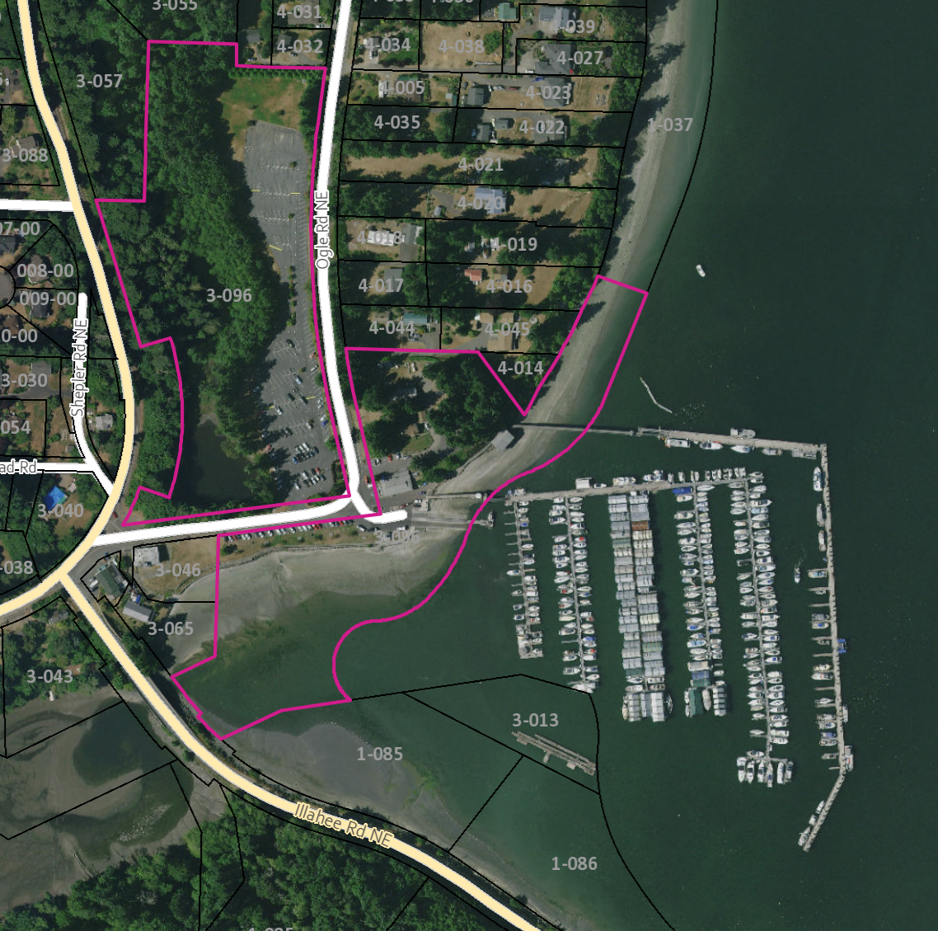
Area includes the upland properties & buildings in the pink outlined areas, as well as parcel 3-046 and the marina in the image.

A plan would include comprehensive camera coverage of the key areas within these areas.

Key areas:
- Marina with breakwater
- All Parking Lots
- Maintenance Yard
- Boat ramp

