REQUEST FOR PROPOSALS FROM QUALIFIED VENDORS
SECURITY LIGHT INSTALLATION

Proposal Due: February 5, 2025, 5:00 (PST)

Port of Brownsville
9790 Ogle Rd
Bremerton, WA 98311

Attention: Robyn Dally
Port Manager

Notice of Request for Proposals

RFP: Security Camera Installation
The Port of Brownsville a small public port in Bremerton, WA is seeking a qualified service to install security light repair & installation for the Marina and Port Properties. Full scope & RFP can be obtained by contacting POB@portofbrownsville.org. The deadline to submit bids by 2/5/25. All further questions can be sent to POB@portofbrownsville.org

Notice to be published: Bid Published to Bonfire.

Notice is hereby given that sealed bids for, The Port of Brownsville Security Cameras located in Bremerton, Washington will be received at the Administrative Offices of the Port of, Brownsville, 9790 Ogle Rd, Bremerton, Washington until 5:00 p.m., Wednesday, February 5, 2025. The official time shall be taken from the designated clock at the Administrative Offices. Any bids received after the specified time and date will not be considered. Bids will then be publicly presented at the Meeting of the Port of Brownsville Commission on February 12, 2025 at 6:00pm.

The scope of work for this project consists of furnishing all labor, materials, and equipment necessary for the project identified above including the following major work items:

Install 2 new Security Lights, to enhance the current lighting for the Port.

Repair or replace non-operational lights on existing light poles or on new contractor-provided poles, buildings, or gates where the contractor identifies the best positions.

Provide and install new buried conduit where as needed based on the contractors plans

A non-mandatory pre-bid meeting for prospective bidders will be held Friday January 24, 2025, at 10:00 AM at the, Port of Brownsville Fire Hall at 9756 Ogle Rd, Bremerton, Wa 98311. A walk through the project site will be conducted after the meeting.

The following forms shall be executed and submitted within five (5) calendar days after Notice of Award.
1. CONTRACT – To be executed by the successful bidder.

2. PAYMENT AND PERFORMANCE BOND – Owner provided form to be completed by Contractor’s Surety and submitted with Contractor executed Contracts.

3. CERTIFICATE OF INSURANCE – Contractor shall furnish a Certificate of Insurance and all applicable Endorsements naming the Port as additional insured on its Commercial General Liability and Automobile Liability Policies.

4. WAGE LAWS COMPLIANCE CERTIFICATION – To be submitted by Contractor with executed Contract.
5. SCHEDULE OF VALUES – To be submitted by Contractor with executed Contract.

6. MATERIAL PROCUREMENT AND CONSTRUCTION SCHEDULE – To be submitted by

Contractor with executed Contract.

7. LIST OF SUBCONTRACTORS – To be submitted by Contractor with executed Contract.

8. PROJECT LABOR RATES AND EQUIPMENT RATES FOR CHANGE ORDER WORK - To

be submitted by Contractor and Subcontractors with executed Contract.

9. CONTRACTOR’S W-9 – To be submitted by Contractor with executed Contract.

The following shall be filed prior to Notice to Proceed.
1. STATEMENT OF INTENT TO PAY PREVAILING WAGES – To be filed immediately by the Prime Contractor after Contract is awarded and before work begins and subsequently by all those providing labor on the project.

BIDS - Having carefully examined the site(s), bid documents, and specifications for Port of Brownsville Security Lights located in Bremerton, Washington the undersigned proposes to furnish all labor, materials and equipment required to perform all work in accordance with the above named documents for the following price. The Total Bid Amount includes all work, regardless of whether or not it is specifically itemized below.

BID SCHEDULE: Port of Brownsville Security Lights
Item No. | Description of Item | Approx. Quantity | Units | Unit Price Dollars/Cents | Total Price Dollars/Cents
1. | Mobilization/Demobilization | 1 | LS | $ | $
2. | Security Lights and repairs | 1 | LS | $ | $
3. | Site Restoration | 1 | LS | $ | $
SUB-TOTAL: $
9.2% WSST: $
TOTAL BID AMOUNT: $

WITHDRAWAL - The above proposal will not be withdrawn within forty-five (45) days after the actual date of the opening hereof.

CONTRACT - If the undersigned be notified of acceptance of this Proposal within forty-five (45) days of the time set for opening of bids, they agree to execute a contract for the above stated sum, and shall bond their work as required by law and that they will begin work within ten (10) days after Notice to Proceed. The undersigned also agrees to execute the contract contained in this Bid Solicitation without modification.

SIGNING AUTHORITY – By signing below, the undersigned hereby acknowledges that they are authorized and duly bound to execute this Bid Proposal Form on behalf of the Contractor and that their signature is binding upon the Contractor. The signing party further certifies that the Contractor represented has visited the Port of Brownsville’s website before the bid due date and time to familiarize themselves with the bid documents and all changes made via Addendum.

CONTRACTOR VERIFICATION - The bidder is instructed to provide with this bid submittal the following registration and identification numbers.

CONTRACTOR REGISTRATION NO.
(insert number here)

DEPT. OF LABOR AND INDUSTRIES ACCOUNT NO.
(insert number here)

EMPLOYMENT SECURITY DEPARTMENT NO.
(insert number here)

WASHINGTON UNIFIED BUSINESS IDENTIFIER (UBI) NO.
(insert number here)

CONTRACTOR - certifies by signing below that they are not disqualified from bidding on any public works contract under RCW 39.06.010 or RCW 39.12.065(3).

CONTRACTOR - certifies by signing below that they have not violated RCW 39.04.370 more than one time as determined by the Department of Labor and Industries.

NON-COLLUSION DECLARATION - CONTRACTOR (as signed below), under penalty of perjury under the laws of the State of Washington, do state and affirm that the quote submitted to the Port of Brownsville is a genuine and not a sham or collusive quote, or made in the interest or on behalf of any person not herein named; and further says that the said Contractor has not directly or indirectly induced or solicited any Contractor on the above work or supplies to put in a sham quote or any other person or corporation to refrain from quoting; and that said Contractor has not in any manner sought by collusion to secure an advantage over any other Contractor or Contractors.

CONTRACTOR - ________________________________

SIGNED - ______________________

Print name and title

ADDRESS -

TELEPHONE - DATE:

Overview of the Port of Brownsville Property
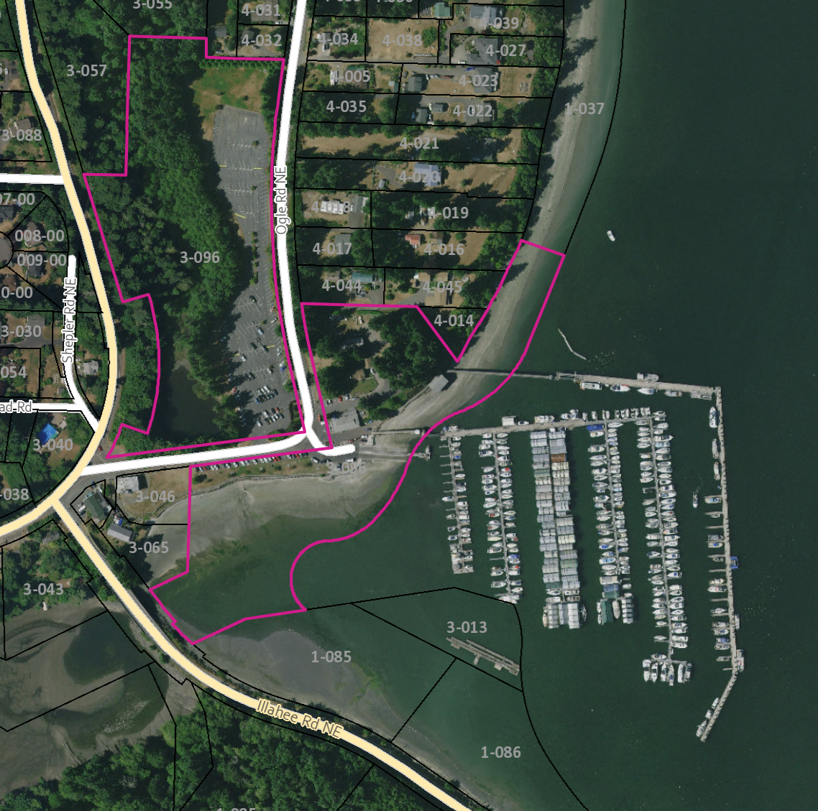
Area includes the upland properties & buildings in the pink outlined areas, as well as parcel 3-046 and the marina in the image.

A plan would include repairs of light coverage of the key areas within these areas. As well as the installation of 2 new lights within the Marina/waterfront parking area

Key areas:
- Marina with breakwater
- All Parking Lots
- Maintenance Yard
- Boat ramp

