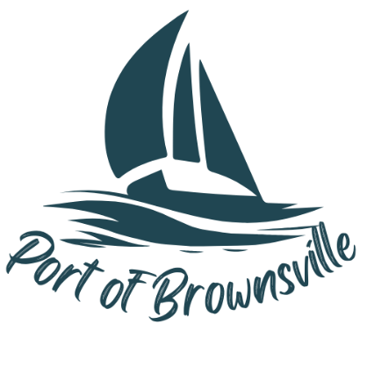

**NOTICE AND AGENDA**

Special Meeting

Port of Brownsville Commission

Thursday February 20, 2025 at 6:00 PM

9756 Ogle Rd, Bremerton, WA 98311

The Board of Commissioners of the Port of Brownsville will hold a Special Commission Meeting on the date and time stated above at the location described above in the Commission Room at 9756 Ogle Rd. for the purposes of conducting, considering, and/or acting on the items listed below:

1. Open Meeting / Call to Order
2. Presentation to the Board
   1. Potential Lease Tenant
3. Discussion of Lease terms & Tenant Selection
4. Executive session (If needed)
   1. The Commission will now adjourn into an executive session to consider the minimum price at which real estate will be offered for sale or lease – RCW 42.30.110(1)(c)
5. Adjourn meeting