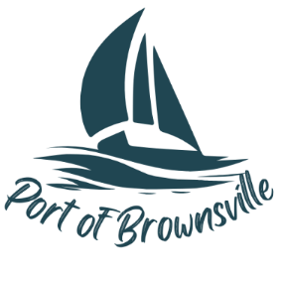

**AGENDA**

Regular Meeting

Port of Brownsville Commission

Wednesday March 19th, 2025 at 6:00 PM

9756 Ogle Rd, Bremerton, WA 98311

And VIA ZOOM

1. Open Meeting / Call to Order
2. Pledge of Allegiance
3. Approval of Agenda
4. Approval of Consent Agenda

All matters listed under the Consent Agenda have been distributed to each member of the Commission for reading and study, are routine, and will be enacted by one motion of the Commission with no separate discussion. If a separate discussion by a commissioner is desired, that item may be removed from the Consent Agenda and placed under New Business.

* 1. Meeting Minutes from February 2025 Regular Meeting, January 23, 2025 Special Meeting, January 28, 2025 Special Meeting, March 4, 2025 Special Meeting
  2. The following checks and electronic payments are approved for payment:

|  |  |  |
| --- | --- | --- |
| The following payments and checks are approved for payment from the Port's General Fund: | | |
|  |  |  |
| Payroll |  | $25,497.82 |
| Payroll Liabilities |  | $12,833.55 |
| Electronic Funds |  | $11,812.42 |
| Accounts Payable Checks  CHECK NUMBERS 51656-51682 | | $199,274.90 |
|  |  |  |
| For a Total Accounts Payable of: | | $249,418.42 |

1. Citizen Comments for items not listed on this agenda. LIMITED TO 3 MINUTES
2. Presentation to/from the Board
   1. Ken McEwan
3. Information, Staff, and Committee Reports
   1. Manager’s Report
   2. Maintenance Report
4. Old Business
   1. Fiber Installation
   2. Camera installation.
5. New Business
   1. RFA Peter Lundblad refund
   2. RFA Steven Johnson refund
   3. Review of Bids for Landscape Maintenance
   4. RFA Summer Staffing jobs
   5. Resolution 25-05 Change of Headcount
   6. Resolution 25-06 Update to Procurement Policy
   7. Resolution 25-07 Resolution for Treasurer & Auditor Bond
   8. Resolution 25-08 Delegation of Authority
6. Public Comment for items listed on the Agenda. No response from the Port during this period.
7. Executive Session
   1. To discuss with Port legal counsel litigation and/or potential litigation including legal risks of a proposed action or practice under RCW 42.30.110(1)(i).
   2. To consider the minimum price at which real estate will be offered for sale or lease when public knowledge regarding such consideration would cause a likelihood of decreased price under RCW 42.30.110(1)(i).
   3. To review the performance of a public employee RCW 42.30.110(1)(g).
8. Close Meeting / Adjourn