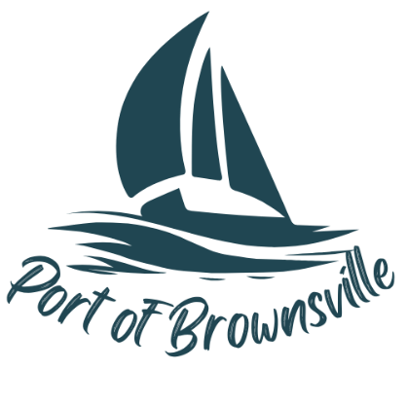

**NOTICE AND AGENDA**

Special Meeting

Port of Brownsville Commission

Wednesday March 26, 2025, at 9:00am

9756 Ogle Rd, Bremerton, WA 98311

The Board of Commissioners of the Port of Brownsville will hold a Special Commission Meeting on the date and time stated above at the location described above in the Commission Room at 9756 Ogle Rd. for the purpose of conducting, considering, and/or acting on the items listed below:

1. Open Meeting / Call to Order
2. RFA for leveling and polish of Deli space and bathroom floors
3. RFA for Walk-in Reefer replacement/repair
4. Recess into Executive Session pursuant to RCW 42.30.110(1)(g) to review the performance of a public employee