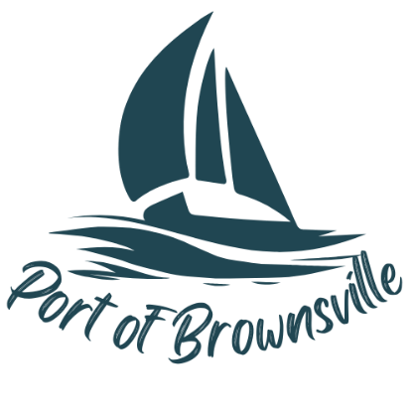

**NOTICE AND AGENDA**

Special Meeting

Port of Brownsville Commission

Tuesday March 4, 2025, at 9:30am

9756 Ogle Rd, Bremerton, WA 98311

The Board of Commissioners of the Port of Brownsville will hold a Special Commission Meeting on the date and time stated above at the location described above in the Commission Room at 9756 Ogle Rd. for the purpose of conducting, considering, and/or acting on the items listed below:

1. Open Meeting / Call to Order
2. Security Camera Walk through
3. Resolution 25-04 Acceptance of donation
4. Resolution 25-05 Acceptance of project completion
5. Recess into Executive Session pursuant to RCW 42.30.110(1)(g) to review the performance of a public employee