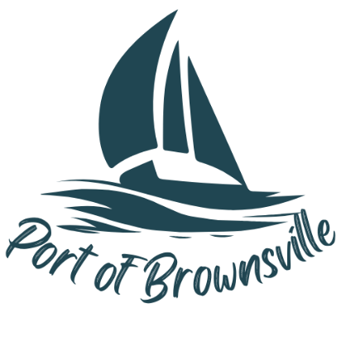

**NOTICE AND AGENDA**

Special Meeting

Port of Brownsville Commission

Thursday April 24, 2025, at 11:00am

9756 Ogle Rd, Bremerton, WA 98311

The Board of Commissioners of the Port of Brownsville will hold a Special Commission Meeting on the date and time stated above at the location described above in the Commission Room at 9756 Ogle Rd. for the purpose of conducting, considering, and/or acting on the items listed below:

1. Open Meeting / Call to Order
2. Approval and Signing of Lease with New Operators
3. MRSC.