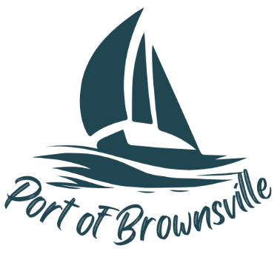
AGENDA
Special Meeting
Port of Brownsville Commission
Monday January 26, 2026 at 1:00pm
9756 Ogle Rd, Bremerton, WA 98311

- Open Meeting / Call to Order
- Executive Session:
  - To review the performance of a public employee RCW 42.30.110(1)(g)

