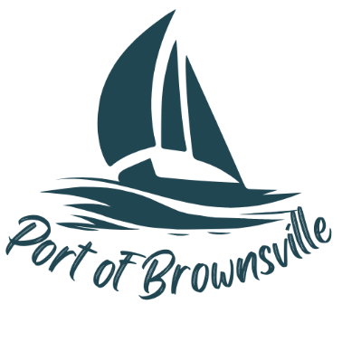
NOTICE/AGENDA
Special Meeting
Port of Brownsville Commission
Sunday July 12th , 2026 at 10:00 am
9756 Ogle Rd, Bremerton, WA 98311

- Open Meeting / Call to Order
- Executive Session:
  - To review the performance of a public employee RCW 42.30.110(1)(g)

No zoom is available for this meeting.

